19/02/2025 – Aula P.W III

Programação Web

Comessando com um projeto do ZERO;

To start the project, we will access the site Spring inicilizr.

group: we will put com.ourname

Artifact & name: Project name

Project: Maven

Language: Java

Spring Boot: 3.4.2

Java 🡪 17

(Tags:

Spring Web

Spring Boots DevTools

Spring data JPA

MySQL Driver)

When we finish to download the project, we will open the file. But, we will select “POM.XML” in the “open” window of intelij (The open file option) to run our project

(Open – Aluno – desktop – project.name – Pom.xml – open – trust file.)

In the package “resources” delete everything BUT APLICATION.PROPERTIES;

In project name. create the directory “domain” (All in minor letters) then, inside domain. We create the directory “model” and inside it create the required class (In this case “Cozinha”);

In the end it should look something like that:

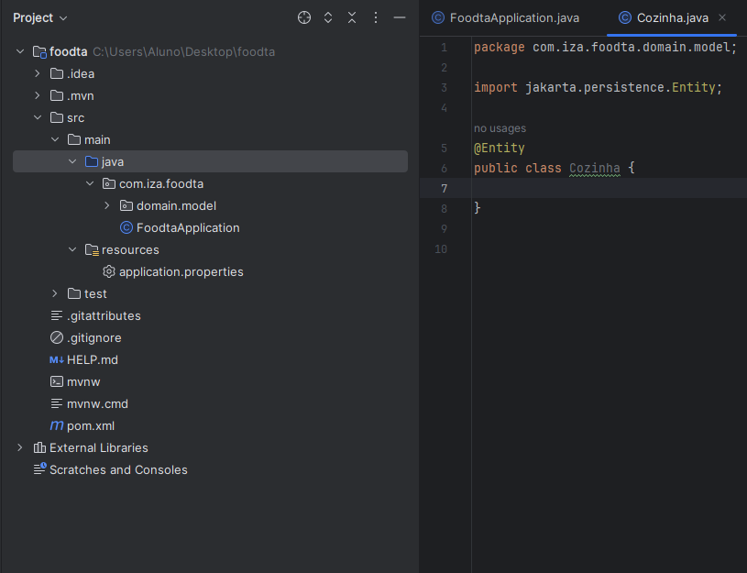

After that, we will head into aplication.properties we will add:

spring.datasource.url=jdbc:mysql://localhost:3306/foodat?createDatabaseIfNotExist=true&serverTimezone=UTC

With defines that if the database does not exist it will create the database, and the date that will be used on the system

spring.datasource.usename=root

“defines” the user;

spring.datasource.password=

Would define a password if we actually used a password, but since is a school project... is not really necessary.

In the end application.property should look like this:

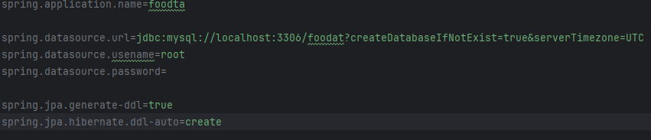

Obs: ADD @TABLE TO CREATE THE DATABASE WISHOUT AN ITEM ON IT; (Didn’t work at all)

After adding a few things on it, the table “cozinha” should look like this:

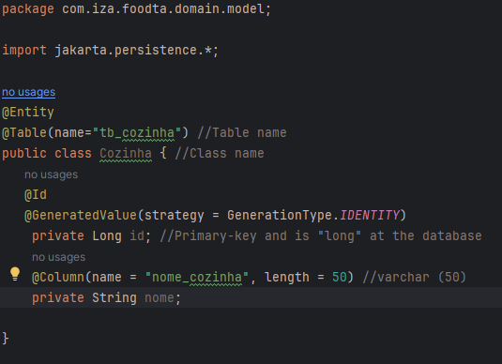

Then we going to create (inside domain.model) we will create a new class called *“Restaurante”*

Add the table restaurant in java, then it should look like this:

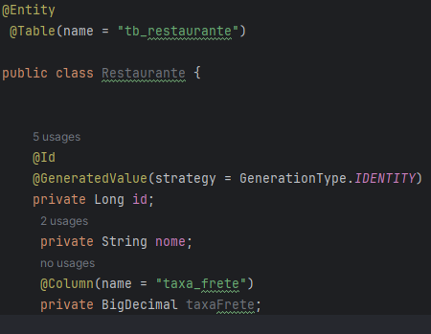

After we create and settle in the restaurant name and type with will be “Big INT” since is long id on inteliJ.

Add equals and hashcode on The “ID” tag only (No need to set it in the restaurant), also add getters and setters in all the tags created till now (once again FOR NOW no need to add nether of those on the restaurant Class.

On POM.XML add another dependency:

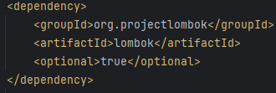

It is supposed to appear a little window on the inferior part of the screen, that says something like “actualize maven” or something like that, then we will open it and install the Lombok (has a pepper logo on the right).

Start shamp, and run the project on MySql.

To Add equals and hashcode we will use the Lombok project, which is the last dependency we added. With it we will add the @EqualsAndHashcode(onlyExplicitlyIncluded = true)

But with a plot.. we will need to add @equalsandhashcode.inclueded because it will include only the table that has that tag. At the end it should look something like this:

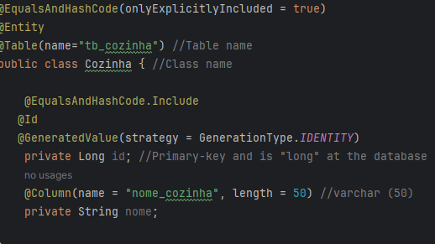

Then we will create more two classes and do the same thing to them.

Após criar as outras tabelas vamos criar mais alguns packages.

sendo estes:

Repository ---> dentro de com.iza.foodta

infraestructure --> dentro de com.iza.foodta

depois, vamos colocar dentro de infraestructure, uma interface chamada CozinhaRepositoryImpl.

(CRUD = SELECT vai determinar o que é listado no postman (mais ou menos isso))

agora dentro de Cozinha repository (intereface) vamos adicionar:

List<Cozinha> listar();

Cozinha buscar (Long id);

Cozinha salvar (Cozinha cozinha);

void remover(Long id);

depois em Cozinha Repository IMPL colocar "implements CozinhaRepository " no nome (public class)

vai aparecer uma lampada vermelha, se clicarmos nela vai aparecer a opção de implementar os metodos e é o que vamos fazer no inicio é normal dar erro no incio anted de implemantar os metodos

depois vamos colocar um @Component a cima de publica class, e logo abaixo do public class á coma dos códigos que foram implematntados vamos colocar:

"@PersistenceContext

private EntityManager manager;"

depois na primeira tag que nós implementamos vamos mudar o resultado do return para:

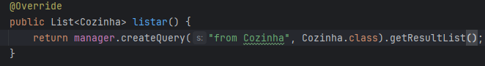

Depois, novamente em com.iza.foodta, create a package named “api” and inside it create another one named Controller with two L’s and inside it create “CozinhaControler” after adding a few things inside it should look like this :

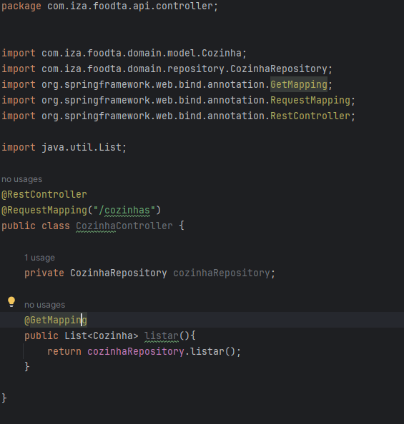

Depois para simular dados no mysql vamos criar uma file (file mesmo sem nada dentro o coizinhho de texto) dentro de recources

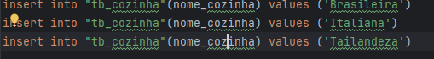

Then in my sql it shoul appear this:

